Ownership Structure
Please attach a diagram of your company's full ownership structure.

Requirements:
- Trace all ownership down to any individual who ultimately holds, directly or indirectly, 25% or more of the Company.
- For every company / trust in the structure (including all holding companies / trust), provide:
  - Entity's full legal name.
  - % of shares it holds in its immediate subsidiary
  - Its total effective ownership % in the Company.
- For every individual owner identified, provide:
  - Full legal name.
  - % of shares they hold directly in their immediate holding company / trust.
  - Their total effective ownership in the Company.

Sample Ownership Structure Diagram
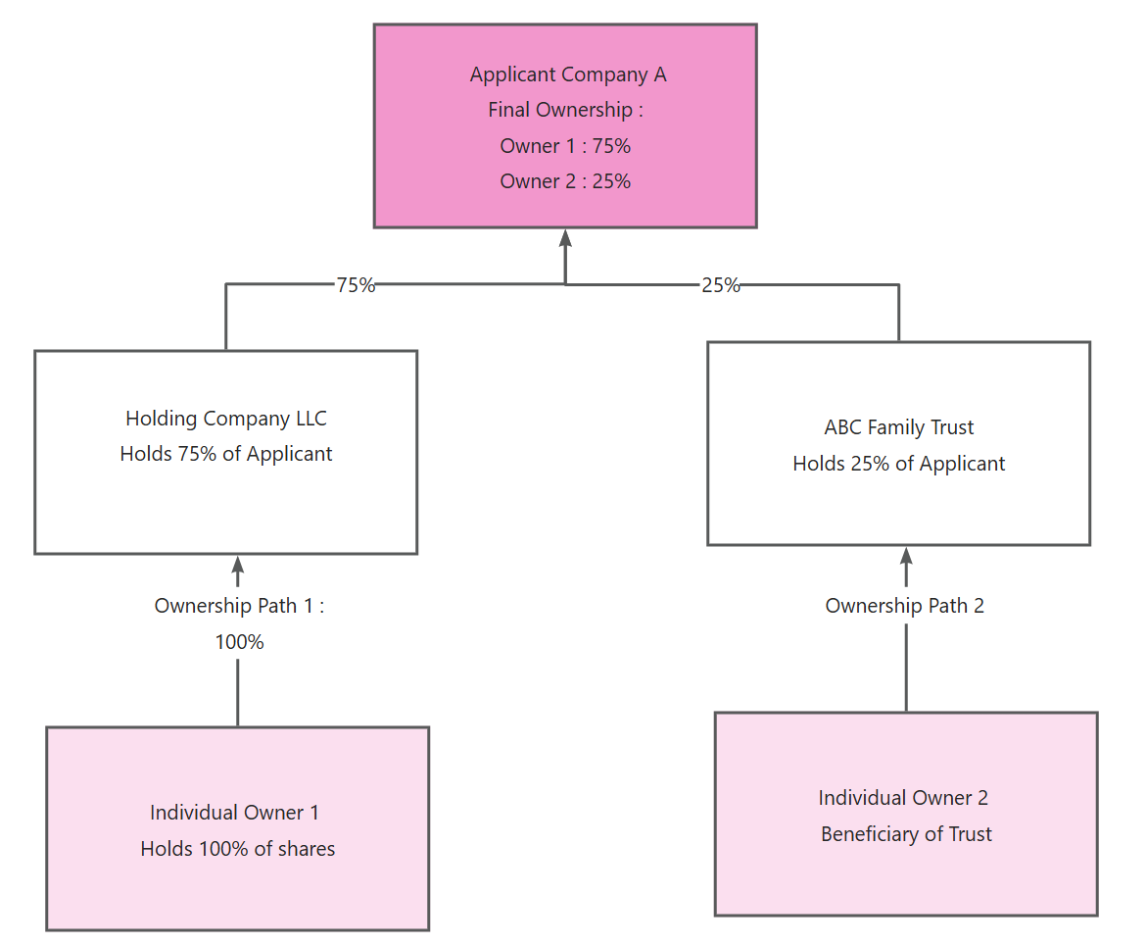
(Please replace above sample diagram with your own Ownership Structure)

☐ I confirm that I have inserted the ownership structure in the space provided above, or alternatively, separately attached/uploaded a copy of a ownership structure as addendum to this form.

Director Name:
Director Signature:
Date Signed:

